**

# 

# 

# 

# **BC2406 Analytics I: Visual and Predictive Analytics**

# 

# **Submitted by:**

# Ng Chi Hui (U1922243C)

# Josiah Goh (U1810793E)

# Jarrel Kong Kai Jit (U1910901J)

# Wang Liang Yi (U1920597H)

# Shaun Leow (U1921323A)

# Yuki Yap (U1910716A)

# 

# **Group Number: 6**

# 

# **Nanyang Business School**

# 

# 

# 

# 

# **Table of Contents**

1: Executive Summary

2: Practical Motivation

3: Increasing inflows

4: Decreasing outflows

5: Data and models

5.1: Data Preparation & Cleaning

6: Exploratory Data Analysis

7: Model Building

8: Insights and Analysis

9: Business Recommendation

10: Appendix

11: References

# **1: Executive Summary**

One of the most important measures of success of asset management firms like White Rock is assets under management(AUM). A steadily growing AUM every year signals growth prospects for the firm.

We have identified 2 main areas that we would focus on in this proof of concept(POC) - increasing inflows and decreasing outflows.

When it comes to increasing inflows, we must first understand our customer segment and how the demographics of the customers affect the products they are likely to invest in. This allows the sales and marketing team to selectively push products that tailor to our client needs. We found that older clients buy more Gold, while younger clients invest more in ETF Tech. Female clients buy more Corporate Bonds and male clients buy more Emerging Market Funds(EMF). Also, clients with more dependents invest more in Private Equity(PE), and clients with fewer dependents invest more in Government Bonds.

On top of that, we have also found that there are some outliers in younger clients aged 30 and below who do not invest in private equity. This is down to the high minimum sum of investment typically associated with investing in Private Equity. As such, we have proposed a creation of a RoboAdvisor, which can help with pooling funds together from these younger clients to invest in Private Equity. With the younger generation being more receptive towards new ways of investing, the RoboAdvisor would be a good way for us to capture this market.

As for reducing outflows, we found that inactive customers who have not made any transactions for more than 201 days and have an annual salary of less than $158,905 are the ones who are most likely to churn. We believe it is crucial to retain them as their average assets with the firm before leaving totals up to $118,861.

# 

# **2: Practical Motivation**

**Problem Statement:** How can we increase AUM for White Rock?

**Business Problem & Approach**

Considering that:

1. White Rock is an investment and asset management company.
2. White Rock and its peers make most of their revenue through management fees (*BlackRock Form 10-Q*, 2020).
3. White Rock collects a lot of data regarding their operation and sales.

Our team believes that our solutions should be something that can help with increasing assets under management (AUM).

AUM can be increased in 3 main ways:

1. New investments from new/existing customers or increasing inflows
2. Retaining investments from existing customers or reducing outflows
3. Higher returns from existing AUM

Rather than rely solely on investment returns to increase AUM which can vary widely from year to year depending on the market’s volatility, a more predictable approach would be to obtain new investments from new or existing customers and to retain as much of their investments as possible.

Thus, for the scope of this POC, we will focus on points 1 and 2 above, namely to increase inflows and reduce outflows.

The analysis and recommendations will be given based on a similar dataset that we would expect from White Rock, with investor demographics and their portfolio information. This is to ensure that the models that we will be using will be relevant to White Rock and that said models are appropriate in terms of analysing similar data.

# 

# **3: Increasing inflows**

The most straightforward way to increase AUM is to increase our inflows. As such, we have devised a solution to increase inflows, which leads to an increase in AUM, all else being equal.

**Method 1: Mapping Relationships**

**Insight**

Our exploratory analysis has shown a few relationships between some of the market segments and the investment products invested, and there were a few that stood out to us:

1. Age: Older clients buy more Gold (Ossinger, 2020), while younger clients invest more in ETF Tech

According to our model, a 70 Year Old investor invests about $3,451.14 more in Gold and $963.90 less in ETF Tech compared to a 25 Year Old investor

1. Gender: Female clients buy more Corporate Bonds (Trueman, 2016), while male clients buy more Emerging Market Funds(EMF)

According to our model, on average, Female Clients invest $5,532.04 more in Corporate Bonds and $7,040.65 less in EMF compared to Male clients.

1. Number of dependents: Clients with more dependents invest more in Private Equity(PE), and clients with fewer dependents invest more in Government Bonds

According to our model, a client with 5 dependents invests about $26,171.71 more in PE and $26,847.39 less in Government Bonds compared to a client with 1 dependent.

While some of our insights can be backed with external research that has been done, we were unable to find any particular research to back up the insight regarding the relationship between Private Equity/Government Bonds and number of dependents.

**Action**

The relationships shown in our analysis can now be a tool useful to us. For example, if we have a new male customer who is 70 years old, and has a low number of dependents, we would be able to suggest Gold, EMF, and government bonds and expect investments of $8598.49, $14,470.43 and $29,019.30, for the funds respectively. If the customer is a current customer who has not already invested in such products, we can also suggest them to him. As such, White Rock can use this analysis to predict the types of products that certain market segments are prone to invest in, and this would in turn increase their inflows.

The models used to derive these insights are found in Section 7: Model Building. We can automatically produce handy profile cards that summarise all the key points that sales teams need to sell to the customers.

**Limitations**

Generally, we are able to recommend suitable portfolio products to customers based on their profile. However, it is also important to note that our insights are not all encompassing, and may vary from client to client. For example, upon our further research, we found that women were more likely to delay their retirement as compared to men with many of them stating that it is due to financial reasons (Mullen, 2020). In this case, if there is a female client who is looking to retire soon, we can recommend purchasing Private Equity as they earn returns that are better than Government Bonds for example (Segal, 2020). This might contradict our insights as a female client who is near retirement age is unlikely to have many dependents, but yet, the investment in Private Equity may suit them more.

**Method 2: RoboAdvisors**

**Insight**

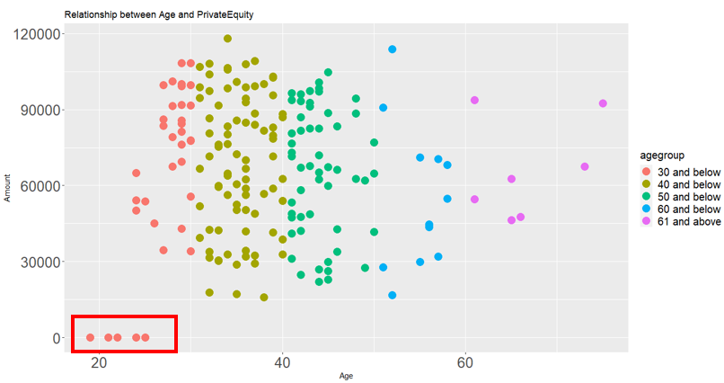

**Fig 1**  **Scatter Plot graph between Age and Private Equity investment amounts**

There are some outliers in the bivariate distribution, where a number of young customers in the age range 30 and below do not invest in PE.

This may be due to the fact that high minimum sums are often needed to invest in PE where it can range from $250,000 (*The Rise of the Robo-advisor: How Fintech Is Disrupting Retirement*, 2018) to millions in some funds.

**Action**

White Rock can create a robo advisor application to target these individuals to allow them to have exposure to the PE market. Through this robo advisor application, White Rock is able to pool the investments from various young investors together to participate in the PE market.

Additionally, this allows White Rock to ride the technological wave, where younger people are more tech savvy and receptive to newer ways of investing (*The Rise of the Robo-advisor: How Fintech Is Disrupting Retirement*, 2018). It is more convenient for this group of people to check their investment portfolio using the mobile application on the go rather than visit their investment manager physically.

There are many benefits for White Rock to launch its own robo-advisory service.

The first benefit is that White Rock just needs to create the application and input the various algorithms to balance the investment portfolios. Additionally, it is easier to maintain these algorithms as investment managers are able to adjust the automated metrics that decide the portfolio allocation.

Second, compared to the usual physical investment consultation with customers, investment managers have more efficient digital means to communicate with customers about their portfolios. This way, White Rock is able to decrease the number of staff handling portfolio management, reducing labour cost in the long run.

Lastly, a robo advisor is able to automate tax-loss harvesting for White Rock. Conditions can be set within the algorithms to execute the purchase and sale of certain similar assets that drop in value to offset increases on other investments. At the end of the financial year, overall tax liability is reduced and portfolio diversification is maintained.

Despite the benefits of a robo advisor, this decision has to be evaluated carefully. In the short term, White Rock has to finance large startup costs to kick start it. The company has to invest in various resources such as application developers and IT infrastructure to create, calibrate and maintain the application for long term use. White Rock might also face competition from existing Robo Advisors thus, it will be good for White Rock to do up a competition analysis to better understand how to differentiate itself. It is projected that White Rock will incur the following costs:

|  |  |
| --- | --- |
| **Total Mobile Application Cost** | |
| **Startup Mobile Application Development Cost** | **Annual Maintenance Cost** |
| $270,000 (Blair, 2017) | 20% (Aparna, 2020) * 270,000 = $54,000 |

*These costs do not include marketing and sales costs to drive application adoption by White Rock customers.

However, from a long term perspective the adoption of robo advisories will speed up the due diligence process and quickly integrate clients into the system. An all integrated centralised system increases White Rock’s ability to manage customers and business change across its business units. If successful, White Rock will enjoy a first mover advantage where they are the only Robo advisors that specialise in private equity for young customers.

It is recommended that White Rock take the following suggestions to ensure proper execution of this new product:

* Charge low fees (Recommended: 0.375% (Royal, 2020) of total amount invested)
* Set a ‘no minimum’ investment amount to target younger investors with little capital
* Set up surveys to ask starting investors about their portfolio preferences, allowing White Rock to create personalised investment advice specific to investors needs. Possible questions include:
  + What is your current annual income range?
  + How long do you plan to hold this investment? (State your answer in the number of years)
  + What is your desired level of return?
* Create different tiers of service based on portfolio amount

**Impact**

Investopedia had done a survey asking young people about their robo advisor usage and found that 20% of them are currently using a robo advisor (Schweitzer, 2019). Assuming 20% of the younger customers will adopt this within the first year with an average AUM of $5000 each at management fees of 0.375% gives $18.75 per customer per year, White Rock will be able to break even with estimated data as shown in the next table.

|  |
| --- |
| **Number of customers needed to breakeven annually** |
| 54,000 / 18.75 = 2,880 |

*These costs do not include all variable expenses such as marketing and sales costs to drive application adoption by White Rock customers

Based on the table above, White Rock will just need a minimum of 2,880 investors per year in order to cover the yearly ongoing costs of this financial product.

Of course the actual adoption rate and average AUM may vary but since usage is currently pretty low, we believe the adoption rate will only increase in the future and so will the average AUM as our younger customers will get older and see more salary increases.

**Implementation**

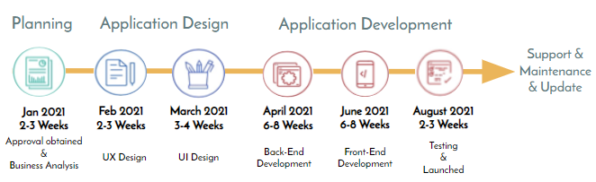

**Fig 2**  **Proposed Implementation Schedule for RoboAdvisor**

This will be the proposed timeline starting from January 2021, where it will take approximately 9 months before the robo advisor application can be rolled out to customers.

# **4: Decreasing outflows**

Increasing inflows would not be meaningful if outflows outweigh the inflows which will eventually result in a smaller AUM, all else constant. Therefore, we have identified a potential solution to reduce churn.

**Insight**

Our model shows that we can predict how a customer is likely to churn based on 2 conditions (click to see model):

1. Whether the number of days since the customer last made a transaction is more than 201, AND
2. Whether the customer’s annual salary is less than $158,905.

At first glance, the first condition seems rather intuitive since inactive customers are more likely to have churned.

But intuition alone will not give a specific number to act on. Our model identified 201 days as the cutoff for inactivity and $158,905 annual salary as the cutoff for lower income customers that need services more tailored for them.

But the second condition where customers earning less than $158,905 are more likely to churn than those who were earning more suggests that we are not serving them as well as our higher income customers. Diving into the data for this group of customers did not reveal additional insights which means that we will need to do more qualitative research and collect more data if possible.

Currently, our model has a 71% accuracy but this figure will likely increase as more data is collected.

**Action**

Moving forward, we should reach out to customers who earn less than $158,905 annually and are approaching 201 days of inactivity. By trying to address their concerns or needs proactively before they leave, White Rock can retain these clients who are at high risk of churning.

For example, White rock can make use of its Customer Relationship Management System (CRM), to send an alert to a customer service representative if a customer has not made any transactions for the past 150 days. This will give us about 50 days to get the customer to engage with us again before they become customers at high risk of churning. It will also be useful to measure this engagement even if the customer did not end up making a transaction. They might not have the funds to invest at the particular time we reached out to them for various reasons, but in our data we could record the important points of the conversation such as the reasons for their inactivity which could then be fed back to our model to make it even better.

For a more qualitative approach, we might find that higher income customers got better treatment or service from our sales or customer support staff which led to higher retention rates as compared to this group. Or there is some unmet need that we did not fulfil and so they turned to our competitors or some other alternative, whatever the case this warrants a deeper look.

To find out whether an approach to retain this particular group of customers is effective, we can do a simple A/B test to compare the churn rate where we intervened versus the churn rate when we did not do anything.

**Impact**

We have found that the average amount of assets each churned customer used to have was $118,861. If the average management fee charged is 0.1% that will be about a loss of $118 in revenue per year. Assuming we have 1 million customers and a current churn rate of 5%, that is a loss of $5.9 million a year in revenue or $5.9 billion in AUM. This figure is likely understated if the number of customers or churn rate is higher. Add to the fact that customers who are still earning an income will increase their investments over time and that markets go up over the long term, the actual loss in revenue or AUM is actually higher.

# **5: A note on algorithmic bias**

Being data driven is good but we have to be mindful of the limitations even if we have an abundance of data. We have to ensure that data captured will cover all our customers across different demographics or we could end up like the financial equivalent of Google tagging black people as gorillas in their Photos app (Grush, 2015).

Another thing we should be mindful of is whether our recommendations align with White Rock’s long term purpose and their customers’ financial goals. For example, the model might recommend less risky products to females as they tend to invest in less risky products. But less risky products usually mean they have lower returns. If a female customer is on track with her retirement plans with the projected rate of return, then recommending less risky products that would not delay her retirement plans are of course good. We help her to retire on time and selling products is also easy.

The problem arises when she is clearly not on track to retire by the time she would like to. In this scenario, continuing to recommend less risky products that have lower returns would only exacerbate this problem even if it is easier to sell less risky products. Human judgement would still be needed to complement algorithmic recommendations to see if she can stomach the extra risk taken on and if she finds it worthwhile to take on this risk if she can retire earlier or have a bigger retirement fund. Thus, recommendations given by the model should be considered alongside the customer’s needs and White Rock’s long term vision of being a trusted financial services company.

# **6: Data Preparation & Cleaning**

**6.1: Drop columns that are irrelevant**

* Drop irrelevant variables like RowNumber, Surname, CustomerID
* Drop CLV because all are null values.
* Drop Retention as it is the opposite of another variable Churn and because all are null values as well.

**6.2: Clean data**

* NA values in financial instruments are assumed to be 0

**6.3: Factor categorical variables**

* Country, Gender, Married, HasCrCard, Mortgage, BusinessOwner, LifeInsurance, Churn

# **7: Exploratory Data Analysis**

Before building the various models, we have decided to take the first step into exploring the dataset, to obtain a better picture of the data we are dealing with.

Since we are interested to learn more about the distribution of various customer groups within the data, we have decided to employ market segmentation variables as a basis for data exploration. Market segmentation is vital for White Rock to divide its target customers into smaller and more focused categories. This helps the company to identify customer needs better and best meet them with the service offerings of White Rock.

We have split the dataset into various segmentation groups like demographic and financial profile (Yesbeck, 2020).

One such group in the dataset contains variables such as CreditScore, hasCrCard and NumBankAccts.

Demographic market segmentation places emphasis on who the customers are in the different customer groups. We have grouped variables like country, gender, married, dependents and age into one big demographic group for visualisation.

We have created some unique splits for customer groups, which combines different types of segmentation variables. For example, EstimatedSalary, Mortgage, Debt, NetAssets, BusinessOwner, LifeInsurance, ForeignAssets are in one group.

As for visualisations, we have decided to proceed step by step by dealing with univariate distributions followed by bivariate distributions. Within each step, we have visualised multiple plots together in the customer groups mentioned above for easier comparison.

**7.1.1 Univariate Distributions: Financial Profile Segmentation**

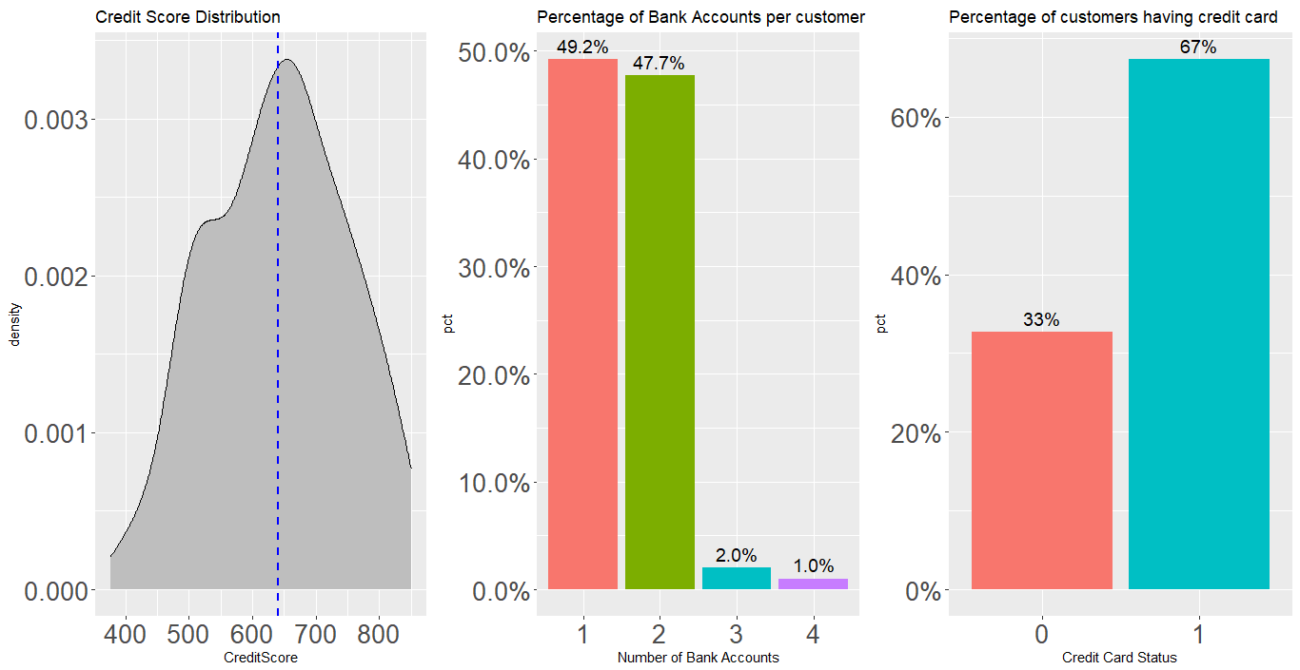

**Fig 3**  **CreditScore, NumbankAccts, HasCreditCard**

The first visualization comprises CreditScore, NumBankAccts, HasCrCard. The first graph shows the density plot of credit scores by each customer, with the mean credit score of 640. This shows that most of our customers generally possess good credit ratings.

The second chart shows that most customers have 1 bank account, with the number of customers having 2 bank accounts following closely behind. Lastly, the third plot shows that most of our customers possess a credit card, which is likely based on their general high credit scores in the first graph.

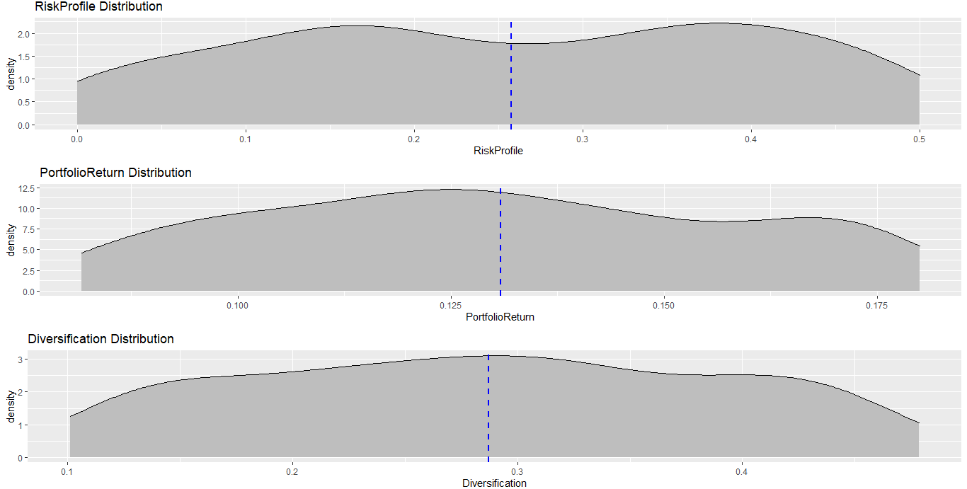

**Fig 4 Diversification, PortfolioReturn, RiskProfile**

The mean of the Risk Profile is 0.26. We also noted that the data for Risk Profile is largely left skewed with the kurtosis value of -1.21. From the graph, there appears to be two different groups of customers, one that has preference for higher risk and one for lower risk.

.The diversification index of customers in the dataset ranges from 0.1012 to 0.4786 which is relatively low. The mean of the diversification index in our dataset is 0.287. In general, customers in this dataset have low diversification.

**7.1.2 Univariate Distributions: Demographic and Geographic Segmentation**

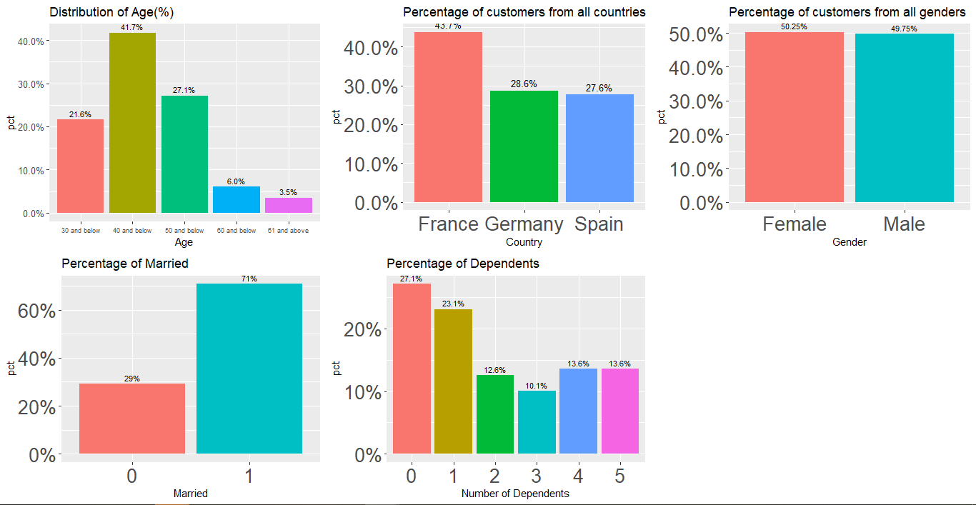

**Fig 5 Age, Country, Gender, Married, Dependents**

Most of our customers in the dataset are younger in age, with most of them centered around 20 - 40 years old. The visualisation also shows that most of our customers are married with less than 2 dependents. The number of females and males is about equal in our dataset.

**6.2 Bivariate Distributions:**

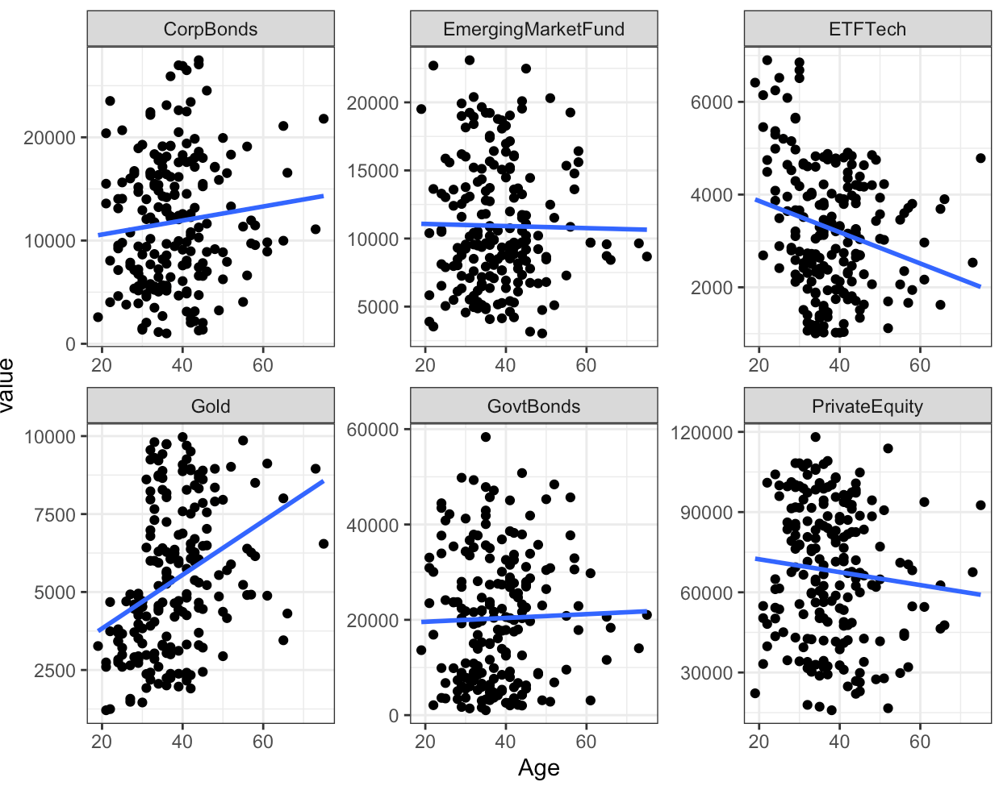

**Fig 7 Relationships between Age and all the financial instruments**

This visualisation plots age against the various financial instruments. It can be seen that age plays a positive linear relationship in corporate bonds and gold but it is negatively correlated with ETF Tech. This may be due to the fact that younger people tend to take more risk (Kane, 2014) as they know that they can afford to ride the market out in the long term.

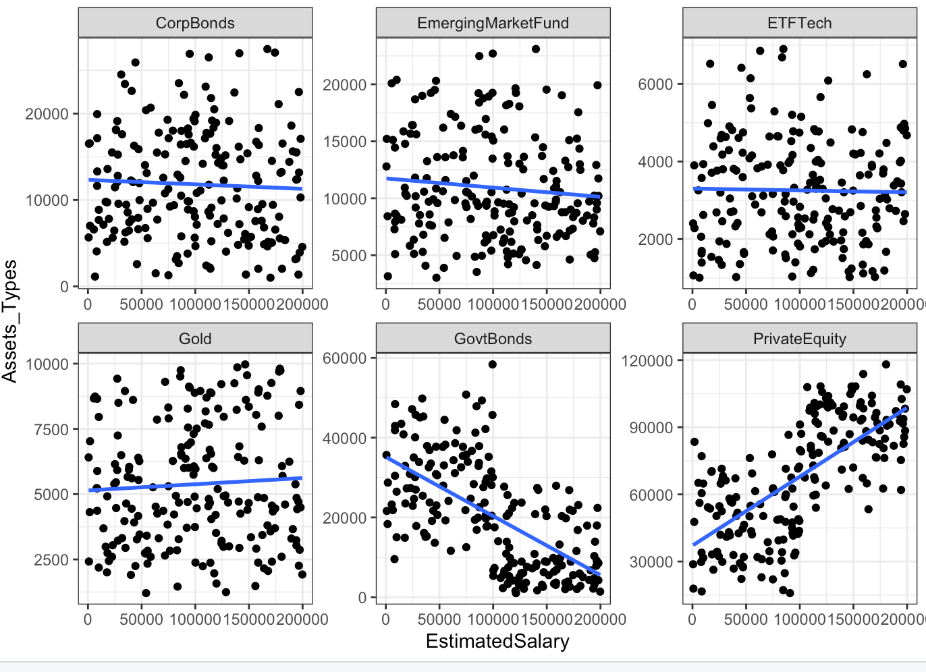

**Fig 8 Relationships between EstimatedSalary and all the financial instruments**

There is a clear relationship between estimated salary and the asset class of government bonds and private equity. The higher the salary, the less likely one is to purchase government bonds. As for private equity, the higher the salary, the more likely one is to purchase private equity assets.

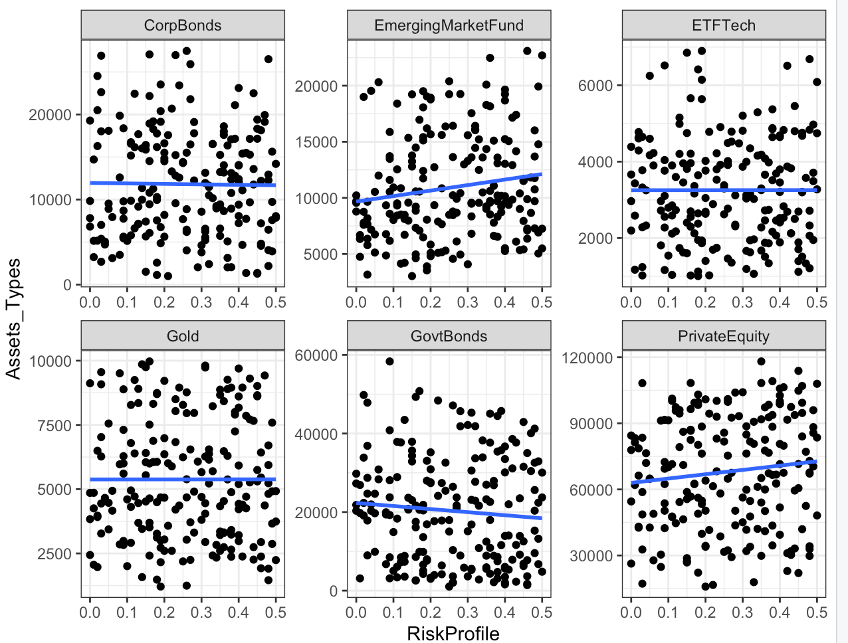

**Fig 9 Relationships between RiskProfile and all the financial instruments**

RiskProfile can be seen to be positively correlated with emerging market funds (r = 0.155) and private equity (r = 0.111) while negatively correlated with government bonds (r = -0.08). This is probably due to the fact that government bonds are more conservative in nature, which suits the lower risk profile of investors.

However, the correlations of these relationships are weak therefore we shall take a more nuanced approach by dropping RiskProfile in our model building.

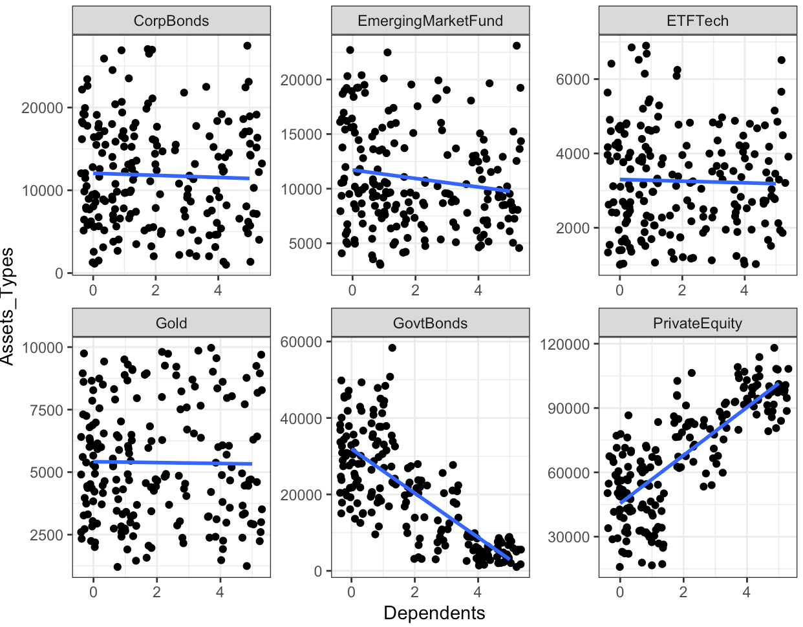

**Fig 10 Relationships between Dependents and all the financial instruments**

The number of dependents is strongly correlated with government bonds and private equity as shown in the visualizations above.

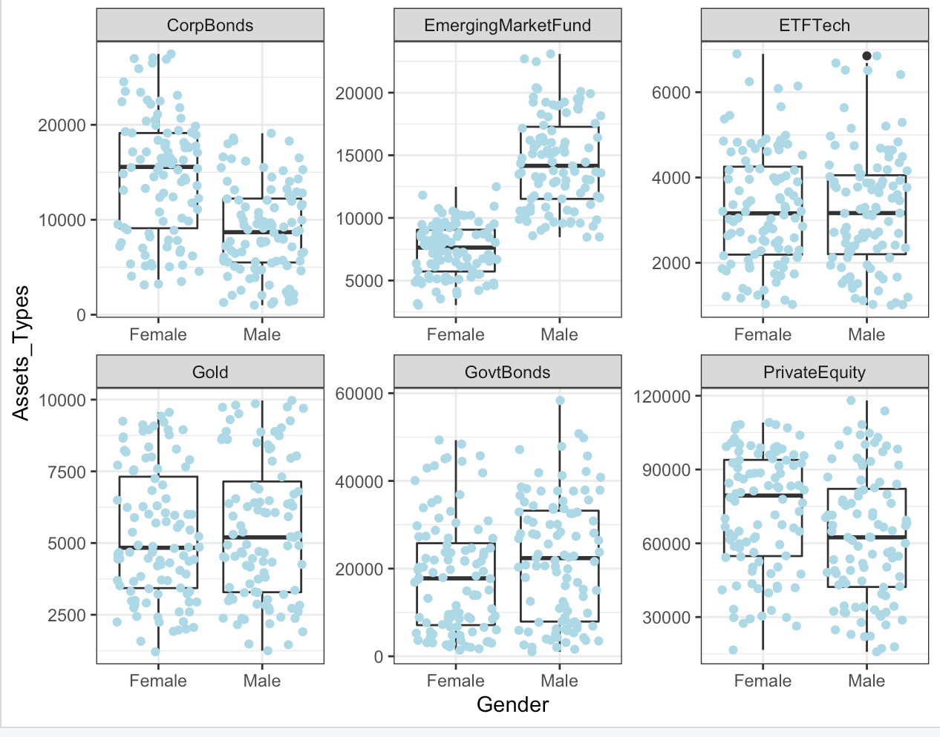

**Fig 11 Relationships between Gender and all the financial instruments**

This visualisation shows that males tend to invest more in emerging market funds, while females invest more in corporate bonds and private equity.

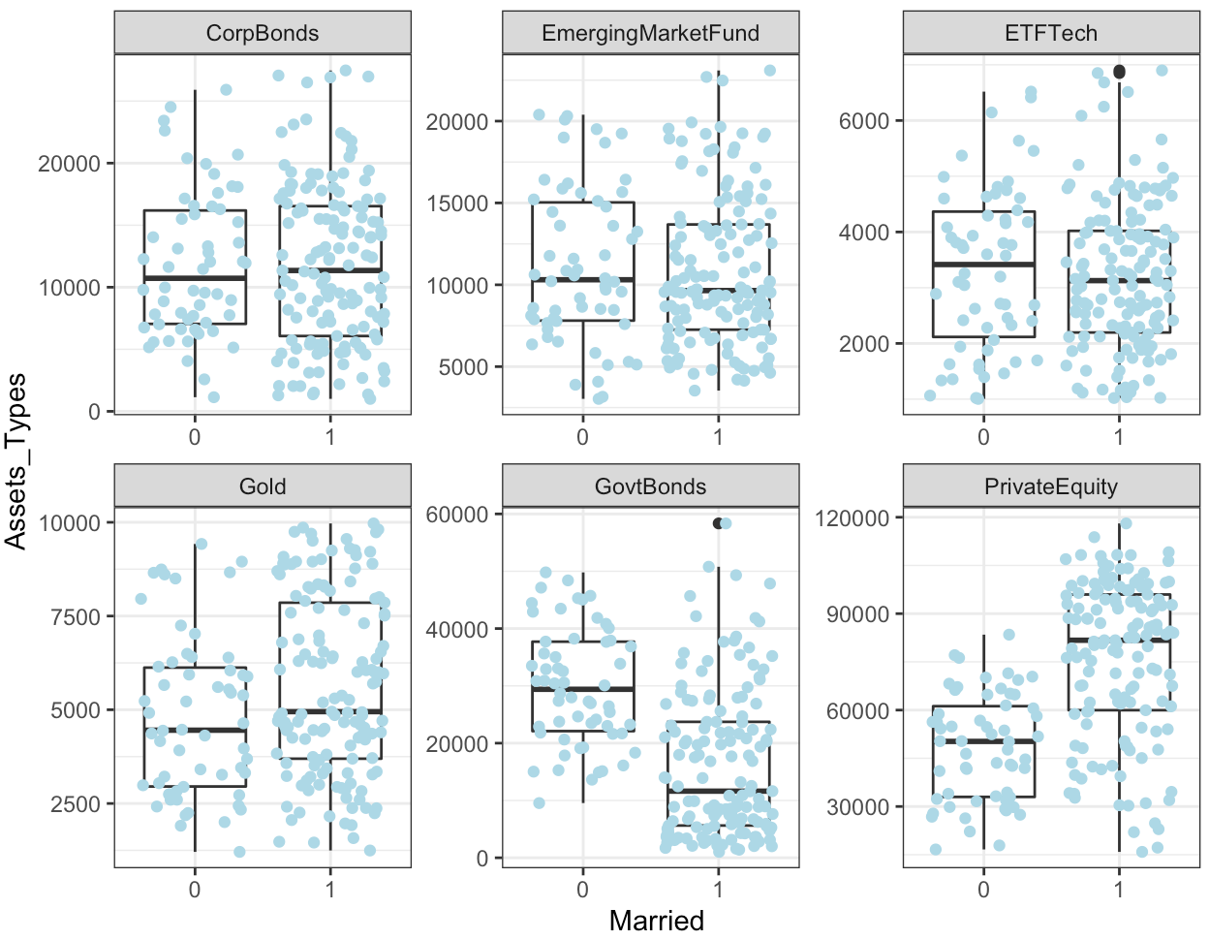

**Fig 12 Relationships between Married and all the financial instruments**

Married customers tend to invest less in government bonds and more in private equity.

# 

# 

# 

# 

# 

# **8****: Model Building**

We decided to employ both classification and regression trees (CART) and linear regression to build our models to derive insights.

**Method 1: Churn model using CART**

After data cleaning, we ran the CART model to find the maximum and minimum tree. And then found the optimal tree based on the 10 fold cross validation error which gives the model below.

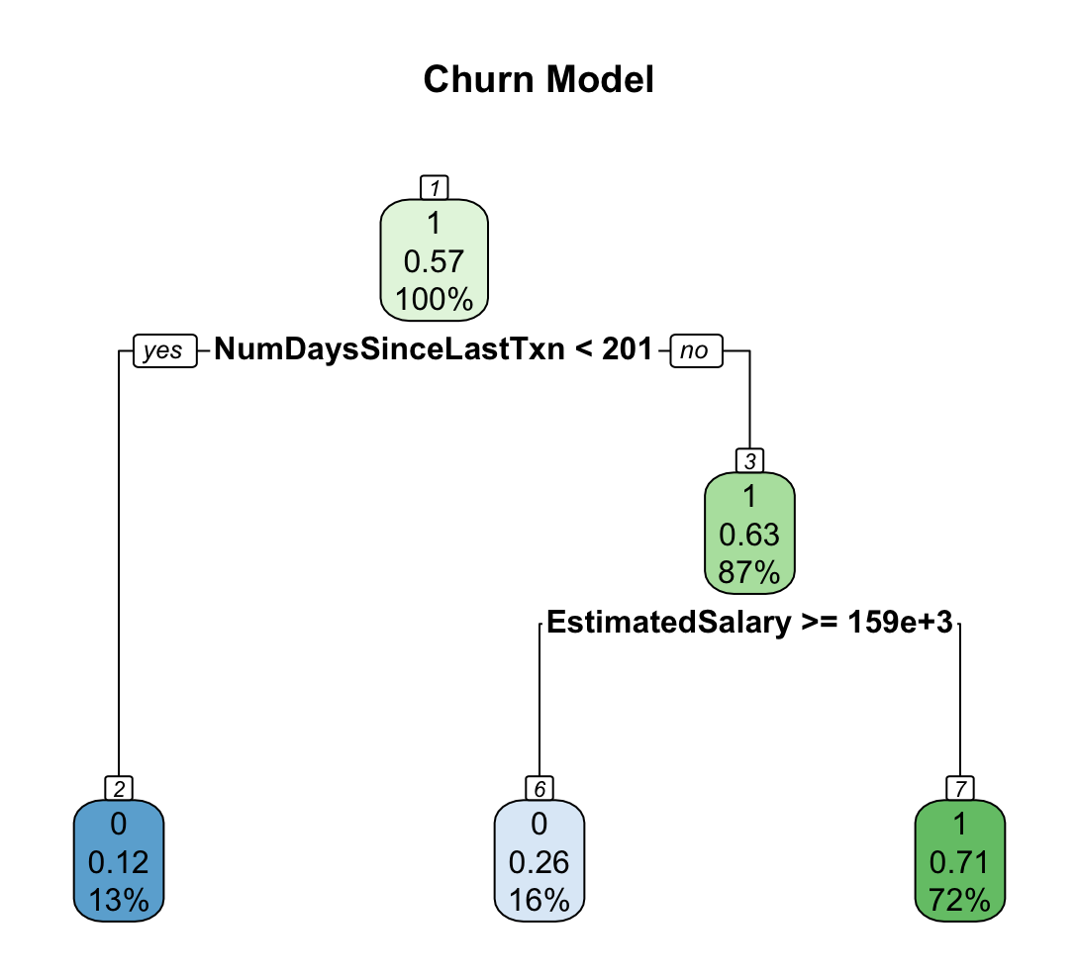

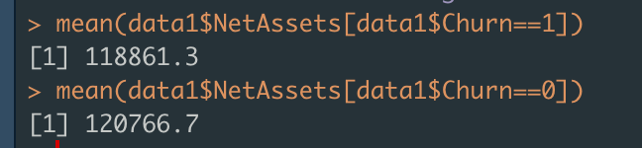

**Fig 13 Churn CART Model**

The CART model shows that clients that had their last transaction more than or equal 201 days ago and an annual salary of more than $159,000 are the most likely to churn.

**Method 2: Linear Regression**

For each financial instrument, we first use all other variables to generate the linear regression model. From there, we check the value of GVIF to determine variables that have high multicollinearity. We then run the linear regression model again without those high multicollinearity variables.

From this, we determine the top 3 or 4 variables that are most statistically significant and run a final linear regression model. Finally, we use train-test split to test our linear regression model for each of the financial instruments. We set seed as 2004. The exact steps are shown in the appendix.

We only show the final linear regression model and the train test split results. The preceding linear regression models codes and results are in the appendix.

The asterisks indicate that the variables are statistically significant while the coefficient estimates show the average change in the given financial instrument when there is a 1 unit increase in the variable, keeping others variables constant.

We want to sieve out variables that are not related to the clients portfolio, but part of their profile such as age, gender and number of dependents. This is so that we can better identify potential clients for each product based on the personal profiles.

**Age:**

Age is a statistically significant variable for ETFTech and Gold.

* **ETFTech**

The final linear regression model’s results.

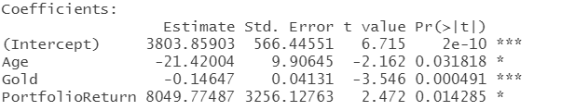

**Fig 14 ETFTech Linear Regression Model**

Age has a negative coefficient estimate which means that as age increases, ETFTech investment decreases. This suggests that younger clients tend to invest more in ETFTech, and older clients less. Although Gold and PortfolioReturn are also statistically significant, they are not part of the profile of the clients.

* **Gold**

The final linear regression model results.

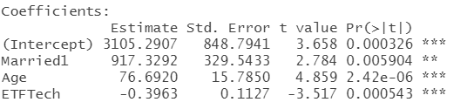

**Fig 15 Gold Linear Regression Model**

Married1 means that those who are married invest more on average in gold than those who are not by the coefficient estimate amount, if all other variables are constant. Age is also a

statistically significant variable with a positive estimate, suggesting that older people buy more gold as investment.

**Gender:**

Gender is a statistically significant variable for corporate bonds and emerging market funds. .

* **Corporate bonds**

The final linear regression model results.

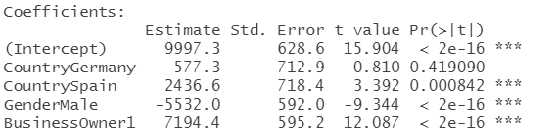

**Fig 16 CorpBonds Linear Regression Model**

GenderMale means that males invest less on average than females by the coefficient estimate amount in corporate bonds, if all other variables are constant. This suggests that females tend to buy more corporate bonds than males.

* **Emerging market funds**

The final linear regression model results.

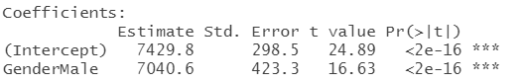

**Fig 17 EmergingMarketFunds Linear Regression Model**

The model shows a positive coefficient estimate for GenderMales, meaning that males invest more than females in emerging market funds on average.

**Number of dependents**

The number of dependents is a statistically significant variable for private equity and government bonds. Although net assets is also a statistically significant variable for both, we focus on the number of dependents to draw insights as the number of dependents coefficient estimates are higher in terms of absolute value for both financial instruments, suggesting a greater impact on the models.

* **Private equity**

The final linear regression model results.

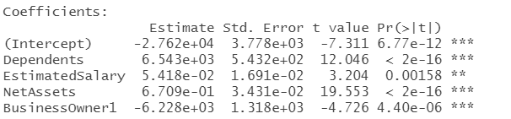

**Fig 18 PrivateEquity Linear Regression Model**

There are 4 statistically significant variables above with dependents having the highest positive coefficient estimate. This means that on average, one’s investment in private equity would increase by the coefficient estimate amount when the number of dependents increases by 1. This suggests that those with more dependents invest more in private equity.

* **Government bonds**

The final linear regression model results.

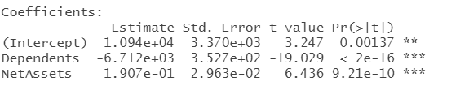

**Fig 19 GovtBonds Linear Regression Model**

Similar to private equity, the number of dependents and net assets are both statistically significant for government bonds. The negative coefficient estimate for the number of dependents suggests that clients with more dependents invest less in government bonds.

# 

# **10: Appendix**

**10.1 Data Dictionary**

|  |  |
| --- | --- |
| Columns | Meaning |
| RowNumber | Identify row number for each record |
| CustomerID | Reference for each unique customer |
| Surname | Each customer’s last name |
| CreditScore | Credit rating of customer |
| Country | Country of origin for customer |
| Married | 0: Not Married  1: Married |
| Age | Each customer’s age |
| Gender | Gender |
| Dependents | Number of dependents customer has |
| ETFTech | Amount invested in tech etf by customer |
| Gold | Amount invested in gold by customer |
| CorpBonds | Amount invested in corporate bonds by customer |
| EmergingMarketFund | Amount invested in emerging market fund indexes by customer |
| PrivateEquity | Amount invested in private equities by customer |
| GovtBonds | Amount invested in government bonds by customer |
| NumBankAccts | Number of bank accounts by customer |
| HasCrCard | 0: Do not have credit card  1: Have credit card |
| EstimatedSalary | Annual salary of customer |
| Mortgage | 0: Does not have mortgage loan  1: Have mortgage loan |
| RiskProfile | Risk index by each customer (The higher the value, the riskier the customer portfolio is) |
| Debt | Amount of debt customer has |
| NetAssets | Total investment amount with the company |
| PortfolioReturn | Average annual return of portfolio |
| Diversification | Diversification index by each customer (The higher the index, the more diversified) |
| BusinessOwner | 0: Does not own a business  1: Owns a business |
| Revenue | Total annual revenue earned from each customer |
| Margin | Profit margin from customer |
| LifeInsurance | 0: Does not have insurance  1: Have insurance |
| NumTransactions | Total number of annual transactions by customer |
| LastTransactionDate | The most recent date of transaction made by customer |
| ForeignAssets | Percentage of foreign assets owned by customer |
| NumProducts | Number of financial products purchased by customer |
| Churn | 0: Remains with the company  1: Left the company |
| Discount | Discount off management fees given to each customer |
| Retention | 0: Left the company  1: Still with the company currently |
| CLV | Customer lifetime value (The higher the value, the more profitable the customer) |

# 

# **11: References**

**Bibliography**

Aparna. (2020, Oct 1). *How Much Does it Cost to Maintain an App*. Mobile App Daily. https://www.mobileappdaily.com/cost-to-maintain-an-app

*BlackRock Form 10-Q*. (2020, June 30). cloudfront.net. http://d18rn0p25nwr6d.cloudfront.net/CIK-0001364742/ac685253-accc-48fb-bacc-4a81d52c6f40.pdf

Blair, I. (2017, Dec 4). *How Much Does It Cost to Build a Mobile App?* buildfire. https://buildfire.com/does-cost-build-mobile-app/

Chomko, R. (2012, May 25). *Maintaining an app is critical to its overall success*. Fierce Wireless. https://www.fiercewireless.com/developer/maintaining-app-critical-to-its-overall-success

Grush, L. (2015, Jul 1). *Google engineer apologizes after Photos app tags two black people as gorillas*. The Verge. https://www.theverge.com/2015/7/1/8880363/google-apologizes-photos-app-tags-two-black-people-gorillas

Kane, L. (2014, Dec 20). *Young People Are Risky Investors*. Business Insider. https://www.businessinsider.com/young-people-risky-investors-2014-12

*Key Benefits of Robo-Advisors in Fintech*. (2019, April 15). Finextra. https://www.finextra.com/blogposting/17140/key-benefits-of-robo-advisors-in-fintech

Mullen, C. (2020, Mar 9). *Women more likely than men to delay retirement*. Biz Journals. https://www.bizjournals.com/bizwomen/news/latest-news/2020/03/women-more-likely-than-men-to-delay-retirement.html?page=all

Ossinger, J. (2020, August 05). *Older investors go for gold*. Economic Times. https://economictimes.indiatimes.com/markets/stocks/news/older-investors-go-for-gold-younger-ones-bitcoin-jpmorgan/articleshow/77376505.cms?from=mdr

*The Rise of the Robo-advisor: How Fintech Is Disrupting Retirement*. (2018, June 14). Knowledge @ Wharton. https://knowledge.wharton.upenn.edu/article/rise-robo-advisor-fintech-disrupting-retirement/

Royal, J. (2020, Oct 1). *Best robo-advisers in October 2020*. Bankrate. https://www.bankrate.com/investing/best-robo-advisers/

Schweitzer, V. (2019, Oct 2). *Only 20% of Affluent Millennials are Using Robo-Advisors*. Investopedia. https://www.investopedia.com/study-affluent-millennials-are-warming-up-to-robo-advisors-4770577

Segal, T. (2020, Oct 7). *Understanding Private Equity*. Investopedia. https://www.investopedia.com/articles/financial-careers/09/private-equity.asp

Trueman, J. (2016, 06 09). *Why women typically take less investment risk*. Investor's Corner. https://investors-corner.bnpparibas-am.com/investing/why-women-typically-take-less-investment-risk/

Yesbeck, J. (2020). *4 Types of Market Segmentation*. Alexa Blog. https://blog.alexa.com/types-of-market-segmentation/